Part 1: Build the Network and Explore Dynamic Trunking Protocol

Step 1: Cable the network as shown in the topology.

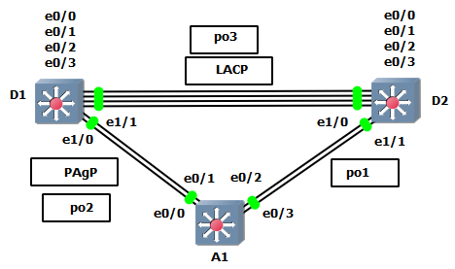

Step 2: Examine the default port status and manipulate DTP.

For this step, we will focus on the connections between D1 and A1.

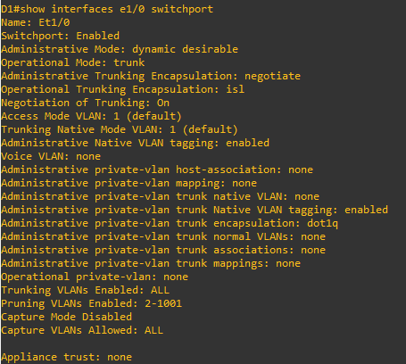

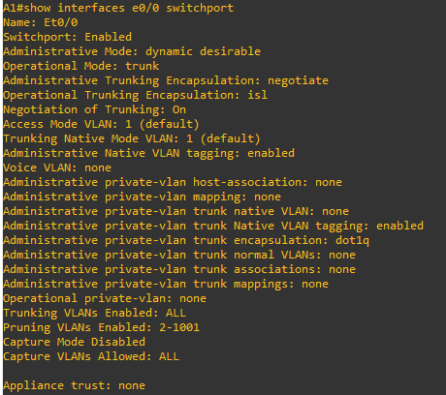

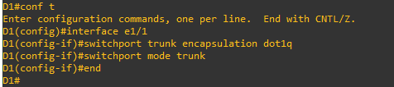

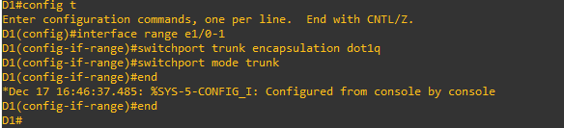

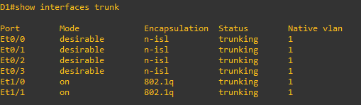

Switch A1

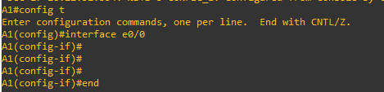

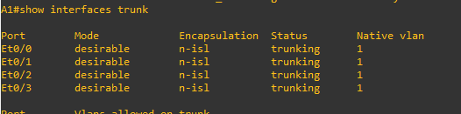

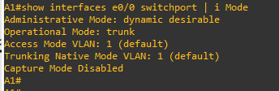

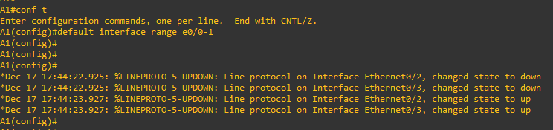

Step 3: Configure Basic Device Settings

Switch D1

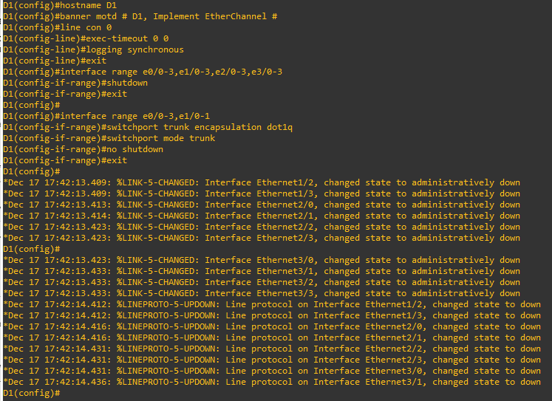

Switch D2

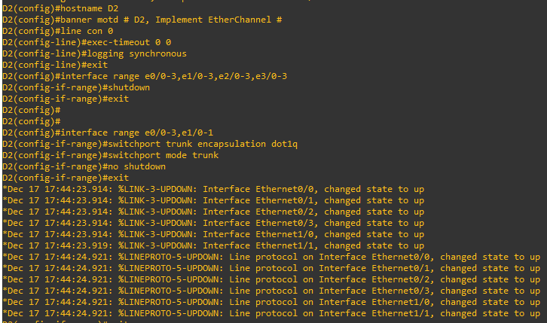

Switch A1 :- 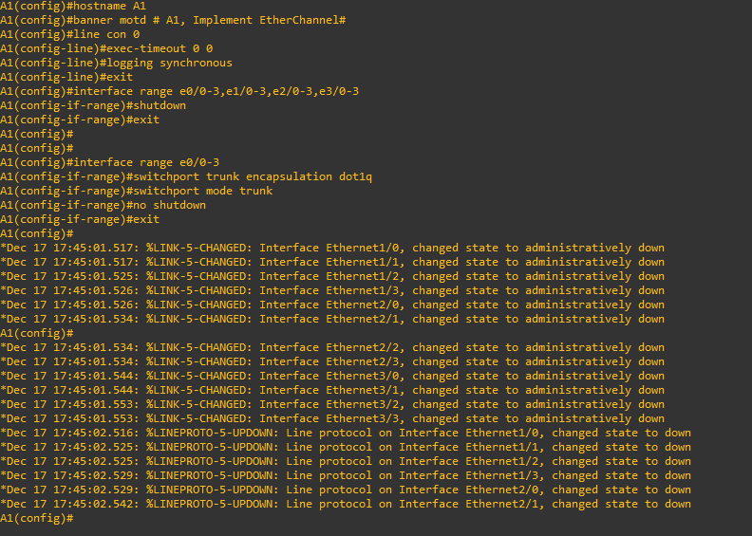

Part 2: Configure Static EtherChannel

########## Switch D2 #########

conf t

interface range e1/0-1

switchport nonegotiate

end

########## Switch A1 #########

conf t

interface range e0/2,e0/3

switchport nonegotiate

end

Step 1: Configure and verify trunking between D2 and A1.

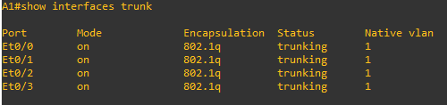

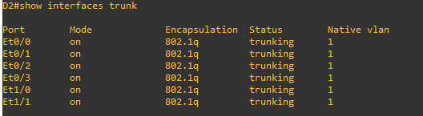

Step 2: Configure and verify a static EtherChannel link between D2 and A1.

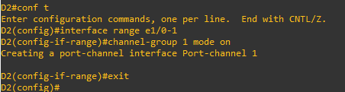

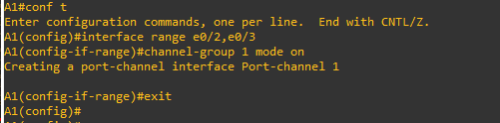

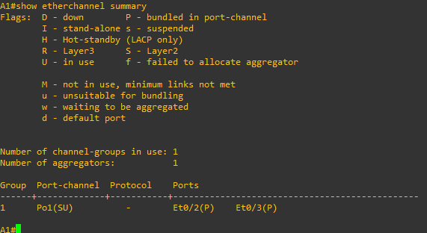

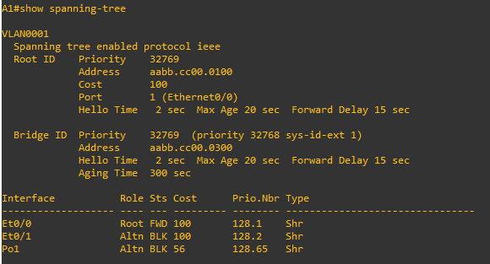

Step 3: Make a change to the EtherChannel.



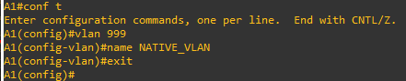

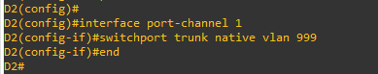

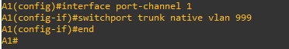

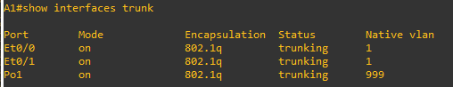

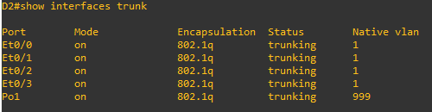

Part 3: Implement EtherChannel Using PAgP

Step 1: Configure and verify trunking between D1 and A1.

a. Configure the ports interconnecting D1 and A1 as static trunk ports with the switchport nonegotiate

command (the startup configuration has the commands to make them a trunk).

b. Verify the trunks are still working.

Step 2: Configure and verify an EtherChannel using PAgP between D1 and A1.

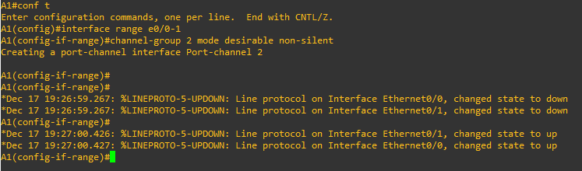

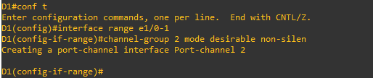

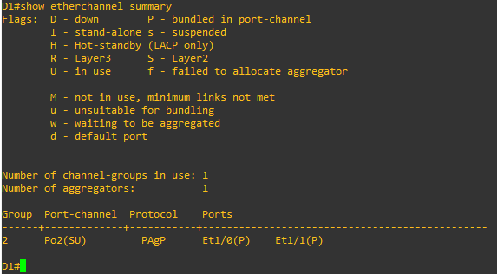

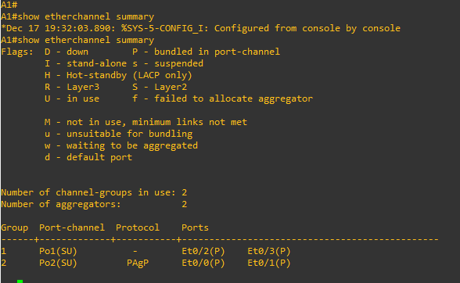

Step 3: Make a change to the EtherChannel.

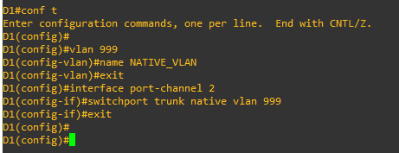

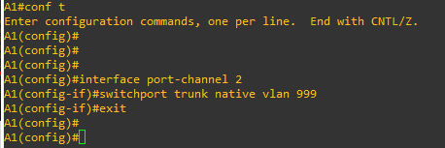

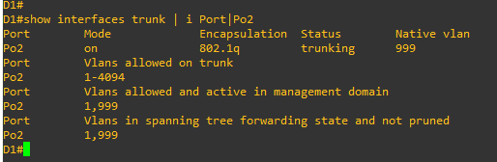

Part 4: Implement EtherChannel using LACP

Step 1: Configure and verify trunking between D1 and D2.

a. Configure the ports interconnecting D1 and D2 as static trunk ports with the switchport nonegotiate command (the startup configuration has the commands to make them a trunk).

b. Verify the trunks are still operational.

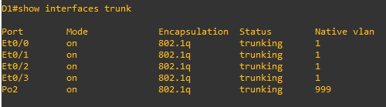

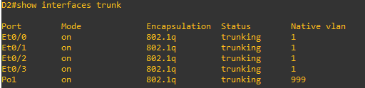

Step 2: Configure and verify an EtherChannel using LACP between D1 and D2.

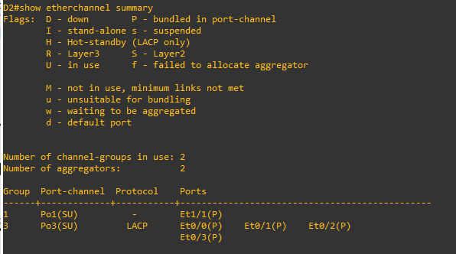

Step 3: Make a change to the EtherChannel.

